CSE 421
LAB MIDTERM
FALL 2014

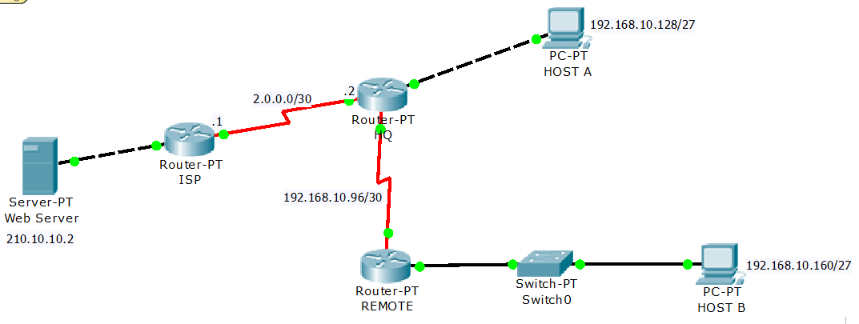
Device | Interface | IP Address |  | Host IP Addresses
ISP | Fa0/0 | 210.10.10.2/30
ISP | S2/0 | 2.0.0.1/30
HQ | S2/0 | 2.0.0.2/30
HQ | Fa0/0 | 192.168.10.158/27 | Host A- | 192.168.10.129/27
HQ | S3/0 | 192.168.10.98/30
REMOTE | S2/0 | 192.168.10.97/30
REMOTE | Fa0/0 | 192.168.10.190/27 | Host B- | 192.168.10.161/27
Note:
- No configuration is required for the ISP Router.
- While creating default route and static route, use next hop’s IP address. Do not use exit interface.
- Use clock rate 64000 if needed.
- Use the following information to configure Router HQ and REMOTE:

1 | The host name | HQ
2 | The password for console (HQ) | cisco
3 | The password for vty terminals (HQ) | cisco
4 | Interface IP Address of all interfaces  of HQ Router | As given in the above table
5 | Enable RIP version 2 in HQ Router and advertise all networks
6 | Create a Default Static Route in HQ Router, towards ISP Router
7 | Create a Static Route in HQ Router for Host B’s network, towards REMOTE Router
8 | Assign IP Addresses of all interfaces  of REMOTE Router | As given in the above table
9 | Create a Default Static Route in REMOTE Router towards HQ Router
10 | Configure OSPF in REMOTE Router with a process ID number of 1 and advertise all networks with area 0
11 | Configure REMOTE Router with a Loopback0 interface of IP 10.1.1.1 and Subnet 255.255.255.255
12 | Assign bandwidth 64 to the serial interface of REMOTE Router
13 | Assign cost 1562 to the serial interface of REMOTE Router
14 | Assign IP address and Subnet Mask to HOST A | As given in the above table
15 | Assign IP address and Subnet Mask to HOST B | As given in the above table

